CEE 3804: Computer Applications for CEE Fall 2014

Quiz 1 (75 minutes)

Date: February 26 Instructor: Trani

Open book and notes, use of computer is allowed

Honor Code Pledge

The information provided in this exam is my own work. I have not received information from another person while doing this exam.

Your Name ________________________________________________

Your Signature _____________________________________________

Write your solutions in a single Microsoft Word file. Cut and Paste all your answers using screen captures of your (in Windows you can use the Snipping Tool - under Programs/Accessories; on the Mac side use Grab - under Applications/Utilities). Show all your work including screen captures of Pivot tables, VBA code and Excel Solver. After you are done, save the single MS file as PDF to avoid artifacts with figures.

Label your file with your last name and CEE3804. For example, my exam file would be AntonioTraniCEE3804.pdf. Email your solutions to Moisés Bobadilla <moisesbm@vt.edu > and to me <[vuela@vt.edu](mailto:yang1990@vt.edu)>. In the email header use the words CEE 3804 Quiz1.

Problem 1 (30 Points)

The data provided in the spreadsheet (see Table 1) contains the aircraft fleet information for two major airlines: Star Airlines and Challenger Airways. Both are in the process of merging into a single airline to be operated under the name Star Airline Inc.

a) Create a Pivot table that shows a summary of how many aircraft of each type the new company will own and the average ages of each aircraft type.

b) Create a second Pivot Table that will display in one column, the average age of each aircraft group for the new company. A second column should show the average number of hours flown by each aircraft type.

1. Find the average age and the number of Boeing 757-200 that belong to the original Star Airlines. Compare the average age of these aircraft with the Boeing 757-200 owned by Challenger Airways.
2. Using another Pivot Table, find the average number of hours flown by Airbus A319 aircraft with engines of the type CFM56-5B6/P.

Table 1. Partial Table with Airline Equipment.

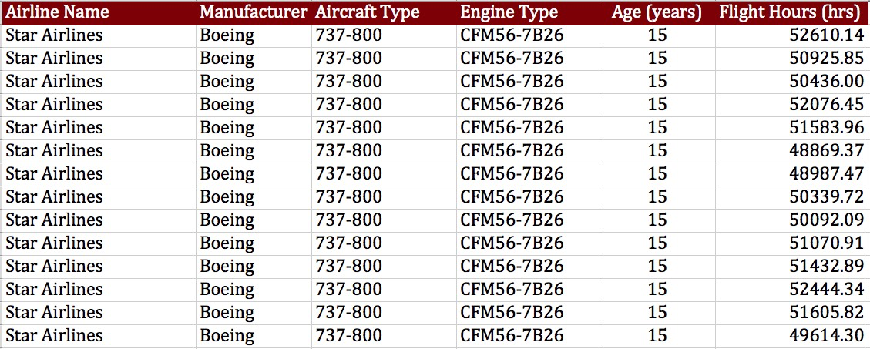

Make sure to make a screen capture of the Pivot Tables used to answer all the questions to get credit.

Problem 2 (35 Points)

A formula used in Coastal Engineering to estimate the transport rate of sediment for beaches exposed to waves is given below in equation (1). **The equation is dimensionally correct so there is no need to check for units in the exam**.

 (1)

**Assume all units in equation 1 are correct.**

1. Write a function in Visual Basic for Applications (VBA) to calculate the value of *Q* given the values of all six variables in the right hand side of Equation (1). The VBA function should produce a single value (*Q*) as output. The values of the six input variables are to be entered in the worksheet. Use the following parameters to test the function:

K = 0.32; s = 2.6; Hb = 3.0; ap = 0.6; alpha = 12, g = 9.81; gamma = 0.9.

1. Write back the result for *Q* obtained in the Visual Basic code worksheet. Label all inputs and outputs appropriately.
2. Test your Excel/VBA function with angles ranging from 0-90 degrees at steps of 5 degrees. Write the results to the worksheet (your choice on where to place the results). Explain.
3. Make sure to make a screen capture of the VBA function code to get credit.

Problem 3 (35 Points)

An engineer formulates a linear programming with two decision variables as follows:



1. Use Excel Solver to obtain the optimal solution. State the optimal value of the objective function.
2. Write down the **first two tables (initial table and the first iteration)** to solve the problem using the Simplex method. In the table indicate what is the Initial Basic Feasible Solution (IBFS) including the values of all variables (both original and slacks, if any).

Make sure to include a screen capture of the Excel Solver panel showing the constraint equations to get credit.